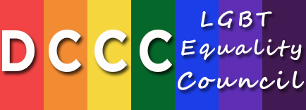

**2015 – 2016 DCCC LGBT Equality Council Schedule**

**2015**

**NYC Breakfast**

**NYC Reception**

**DC Fly-in Event**

**2016**

**LA Event**

**Chicago Event**

**NYC Breakfast**

**NYC Reception**

**DC Fly-in Event**